**Git-01**

Git Bash is already installed in my system.

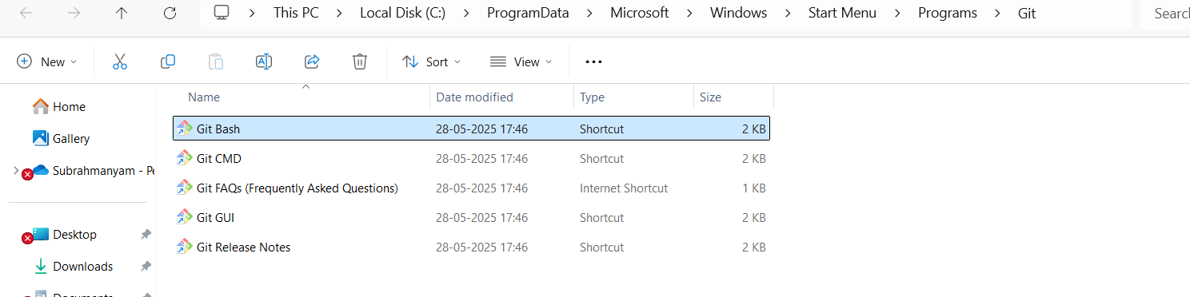

Created GitLab Account and

Created Git Demo Project in GitLab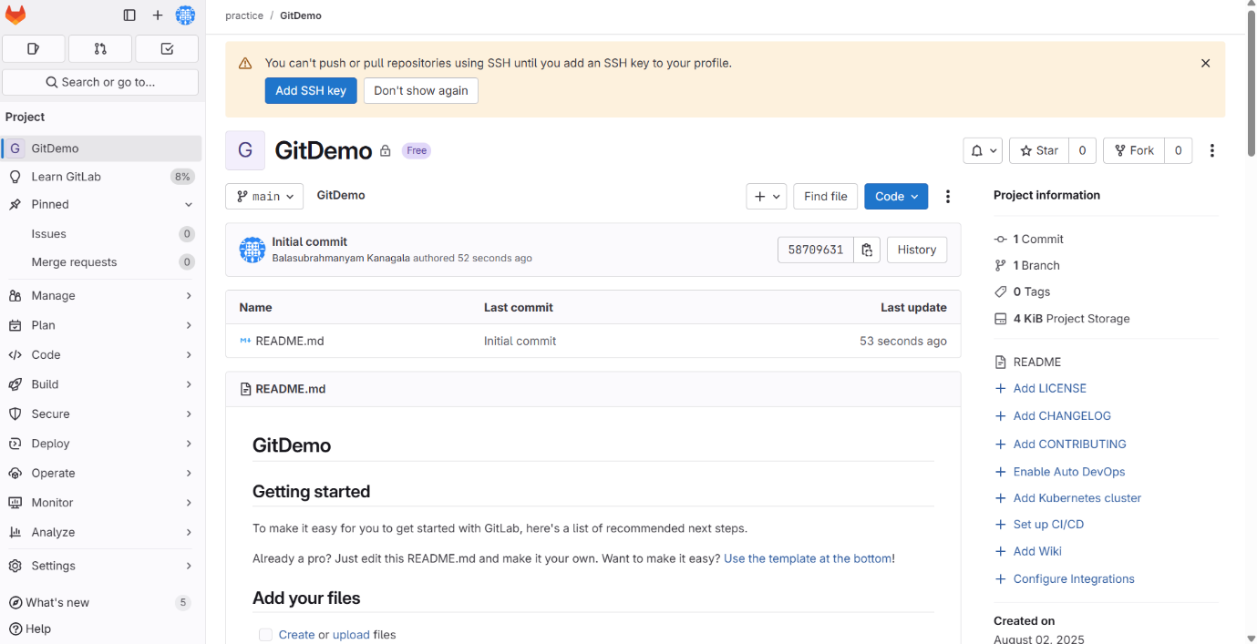

Checked GitClient installed properly or not.

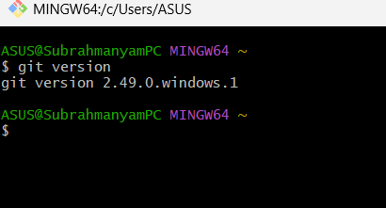

I have already configured user-level configuration

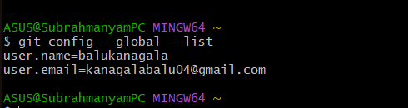

No, Notepad++ in system

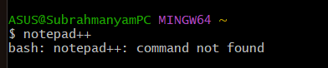

installed it and added its path to environment variables

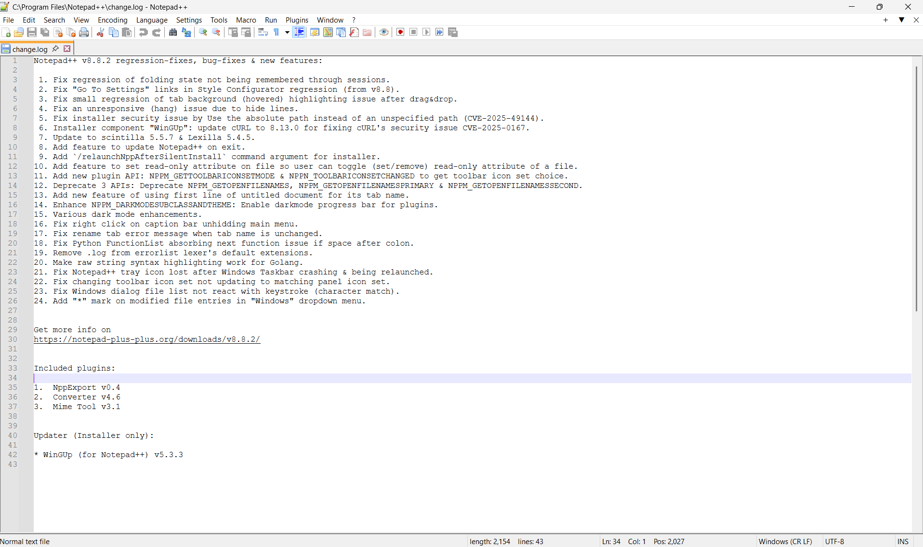

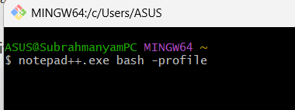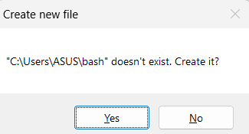

Clicked on Yes, and a bash file got created and added,

Alias npp=’notepad++.exe -multiInst -nosession’ in bash file.

Configured an verified that notepad++ is the default editor for commits and merges messages.

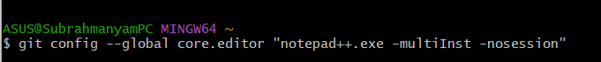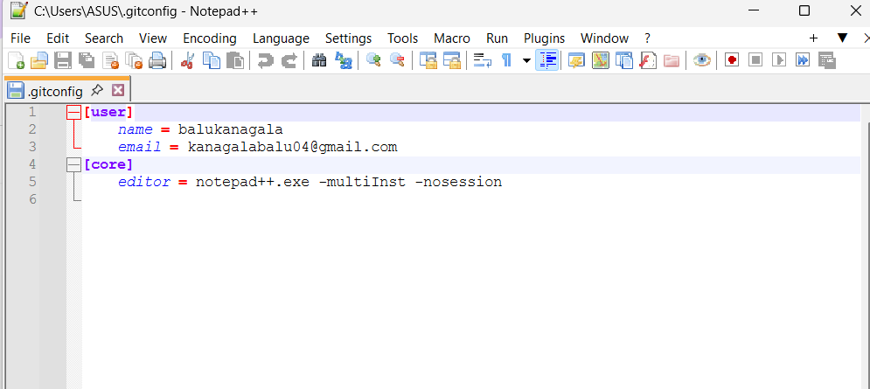

Created a Folder GitDemo and initialized it with git.

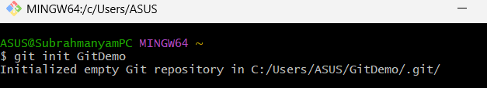

It was showing lot of files bcoz, the I haven’t changed the directory to GitDemo, it was in parent directory to GitDemo.

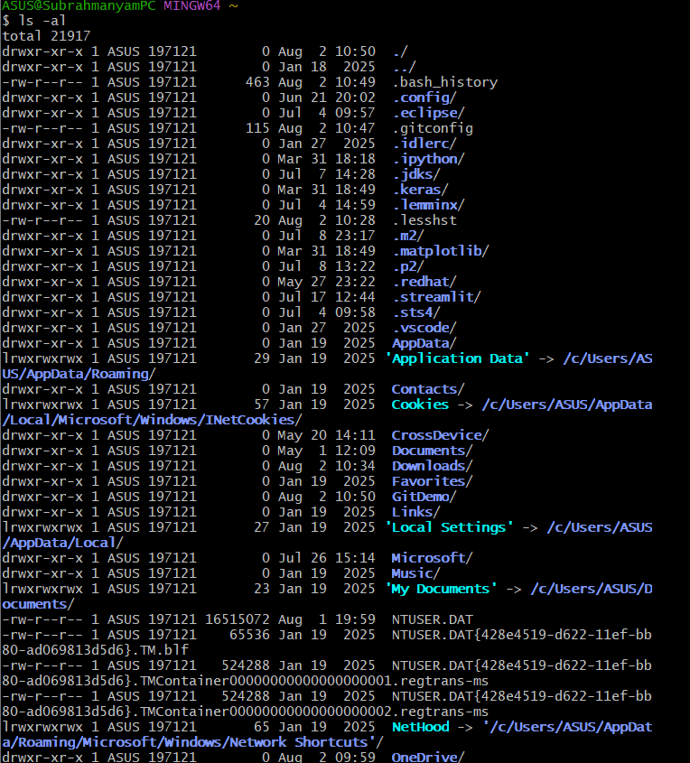

Changed directory, and verified the GitDemo Repository

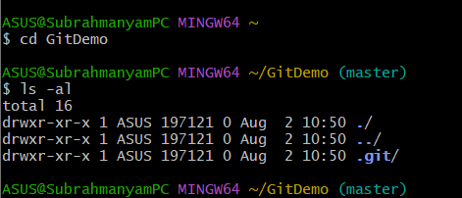

Created welcome.txt

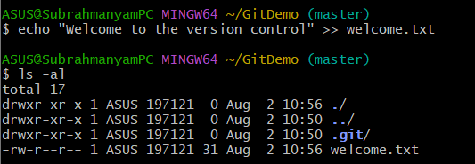

Verified welcome.txt

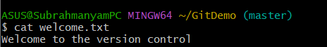

Checked git status

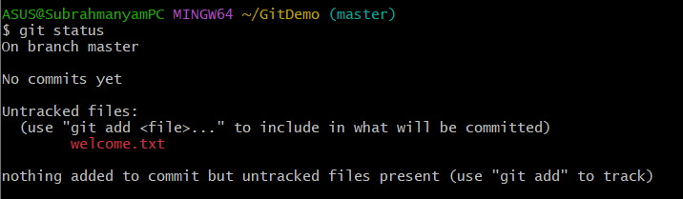

When tried to commit, notepad++ got opened for a commit message.

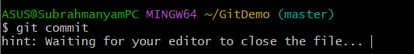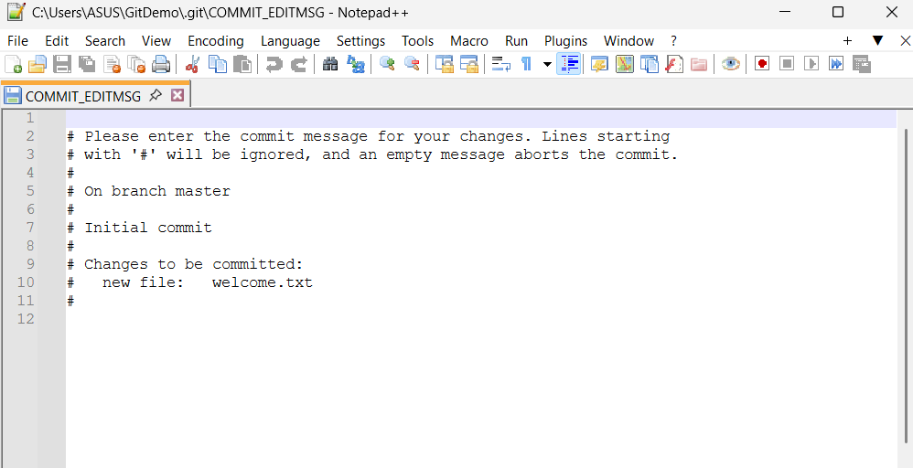

Typed the commit message at the top without #, it got committed.

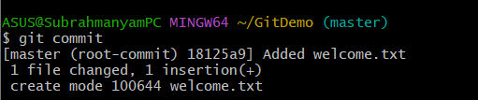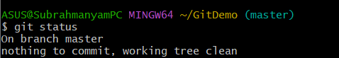

Linked the local repository to the Remote repository on gitlab using the https method.



Verified the link (Connection)

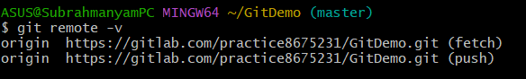

Got an error with master branch,

In gitlab it is main branch

Hence renamed the local branch name to main and set the upstream as well which is necessary.

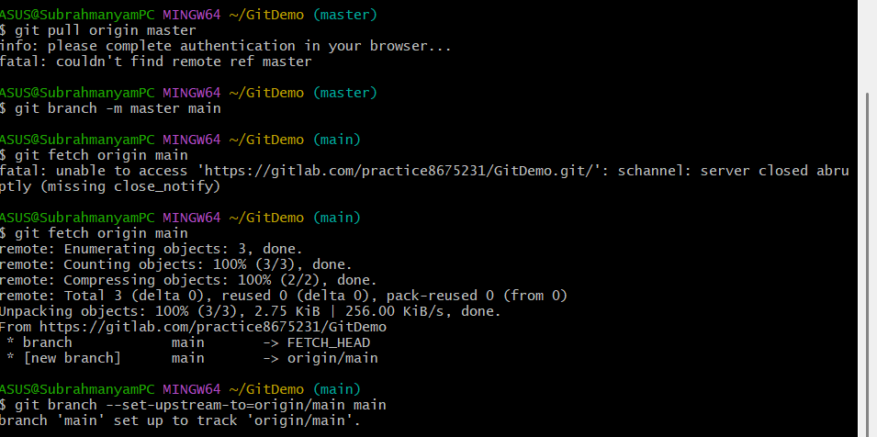

Pulled to local repo from remote repo

--allow-unrelated-histories also pulls, those files even if their histories do not match in local and remote.

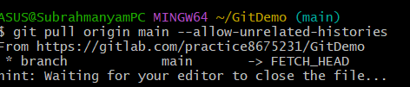

Nothing changed in the merge message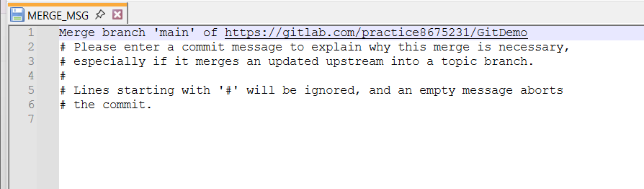

Pulled successfully.

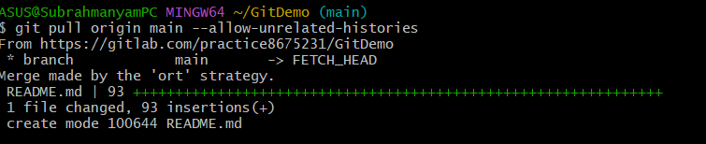

Finally pushed, from local repo to remote repo on gitlab.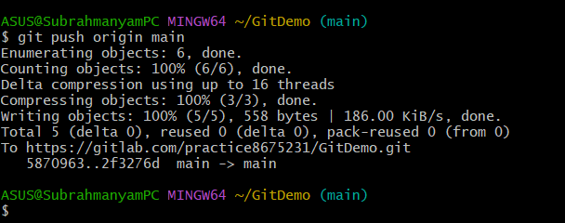

Welcome.txt got pushed into the GitDemo project in gitlab

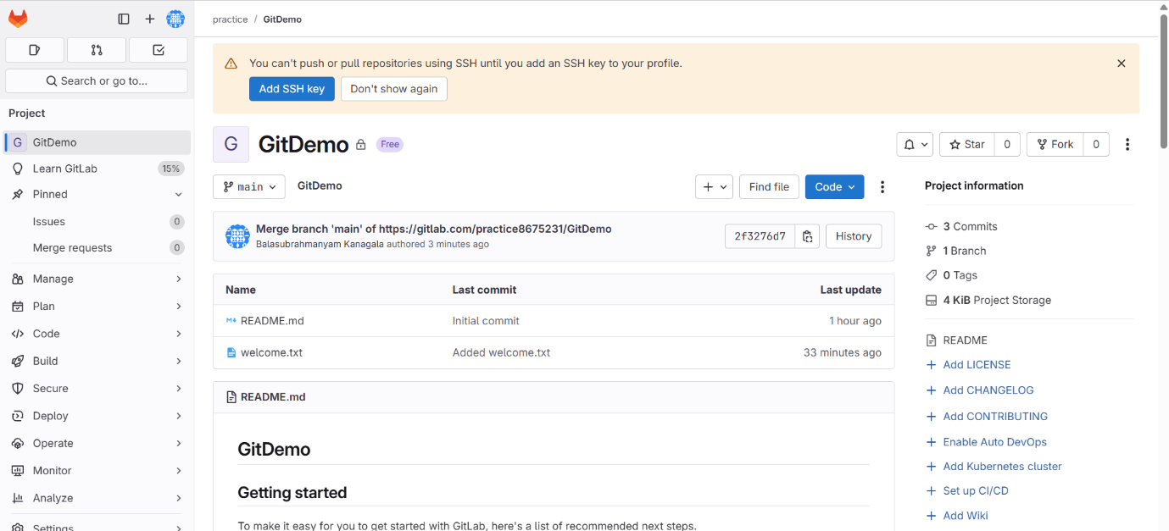

Readme.md got pulled into local system from remote.

